1. How and when to use the AutoSum command in excel?

Ans: If we need to sum a column or row of numbers excel will do the calculation for us. It is mostly used when we have large data to calculate. To use AutoSum, select a cell next to the numbers you want to sum, click AutoSum on the Home tab, press Enter, and you're done. When you click AutoSum, Excel automatically enters a formula (that uses the SUM function) to sum the numbers.

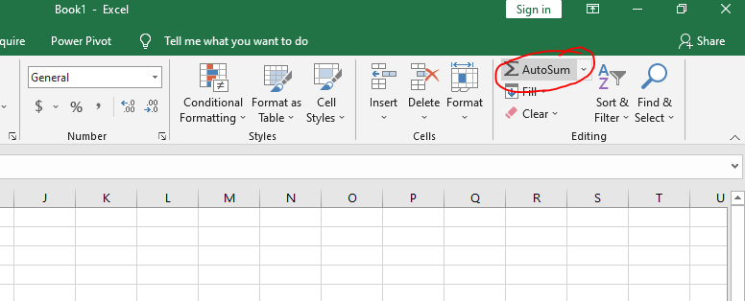

1. What is the shortcut key to perform AutoSum?

Ans: The shortcut key to perform AutoSum is **‘Alt+=’**

1. How do you get rid of Formula that omits adjacent cells?

Ans: To turn off the notification "Formula Omits Adjacent Cells" you're getting, kindly follow the steps below:

1. Open Excel and then click on **File**.
2. Go to **Options**and then select **Formulas**.
3. Look for **Error checking rules** and uncheck **Formulas which omit cells in a region**.  
     
   [Image](https://filestore.community.support.microsoft.com/api/images/8e091f69-ee43-4c89-906c-966c2e513d23)
4. Click **OK**.
5. How do you select non-adjacent cells in Excel 2016?

Ans: The process is given below:

1. Click on the first cell that you want to be selected. This will now become the active cell
2. Hold the Control key on your keyboard
3. Left-click on the mouse and drag to make the selection
4. Leave the mouse click. At this point, you would have a selection. Continue to hold the Control key
5. Place the cursor on the second cell/range that you want to select
6. Left-click on the mouse and drag to make the selection
7. Leave the mouse click. This would select two non-contiguous range of cells.
8. Release the Control key
9. What happens if you choose a column, hold down the Alt key and press the letters ocw in quick succession?

Ans: It will open the column width option.

1. If you right-click on a row reference number and click on Insert, where will the row be added?

Ans: The row will be added the cell we have clicked.